Step 1: Import project in eclipse

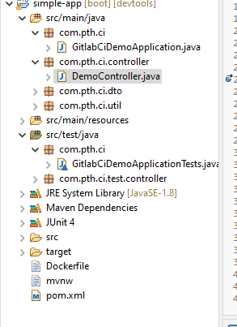

Step 2: Run as Spring Boot App

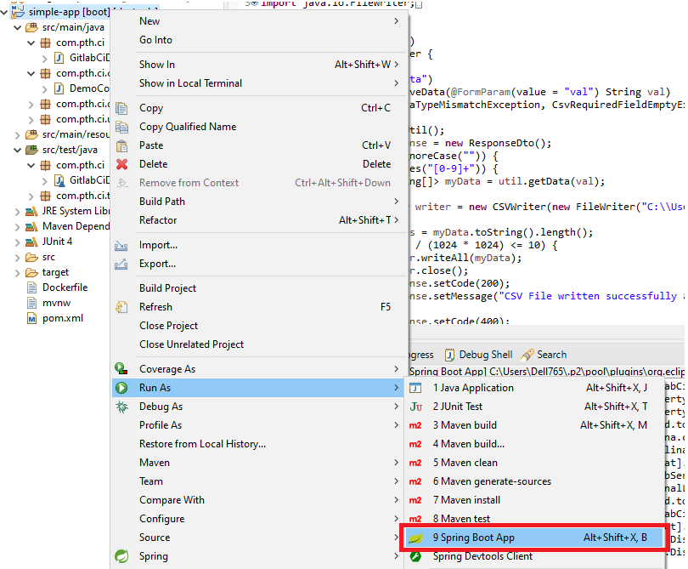

Step 3: Run the application

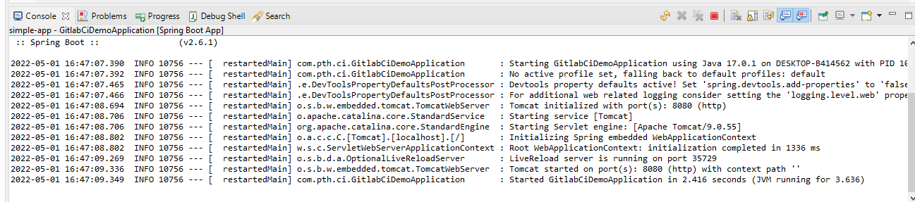

Step 4: Run the API in postman (click on Send) or curl

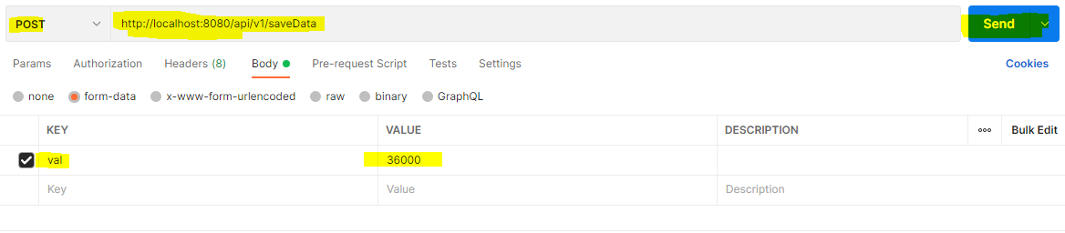

Step 5: Response

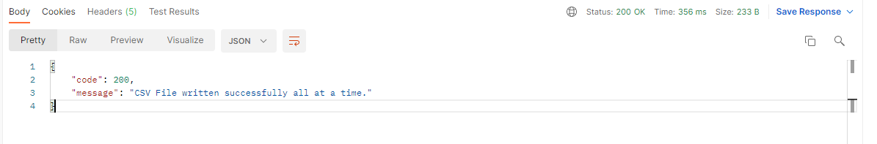

Step 6: CSV



